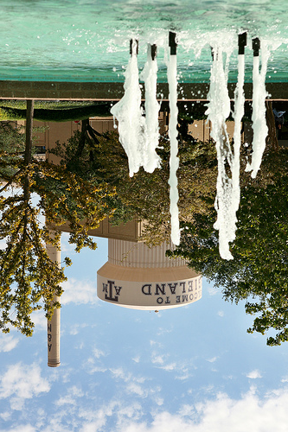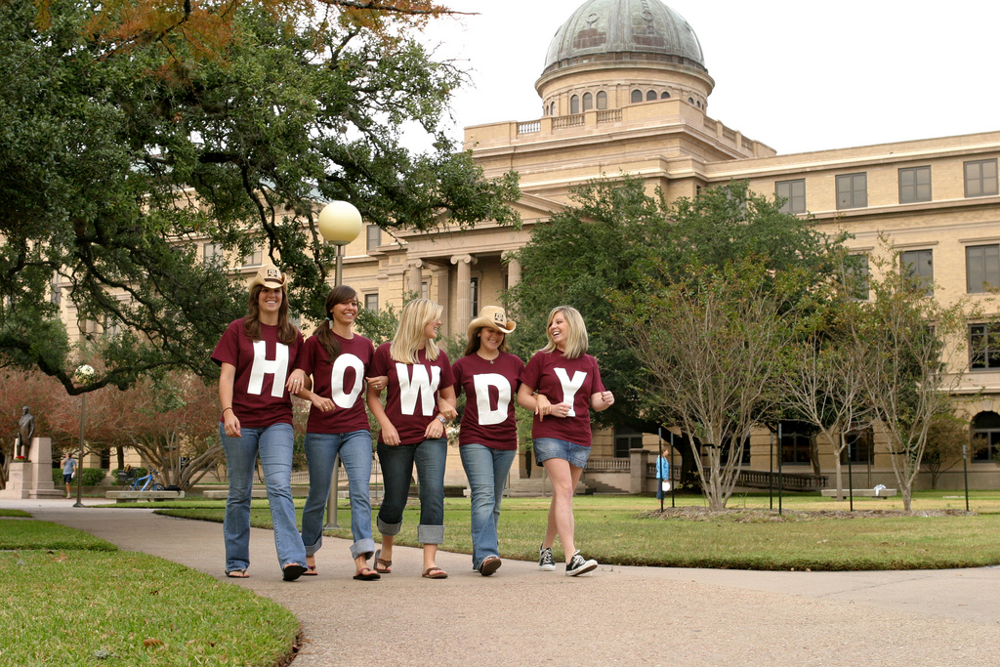

**Although you make it look easy, we know you work hard, and today we honor you for the outstanding work you do all year to make our department successful.**

We couldn’t do it without you!