

# Performance Management: SMART Goals

The Plan stage of the PCER (Plan, Coach, Evaluate, Reward) model of Performance Management encourages the creation of **SMART** (**S**pecific, **M**easurable, **A**chievable, **R**elevant, **T**ime-bound) performance goals, which are documented in Workday. Goals differ from an employee’s ongoing job duties as encompassed in the position description. Performance goals are specific work-related achievements to be accomplished within a specified time frame. They are often project based and are intended to help the organization move forward, typically with a focus on improving processes or implementing changes.

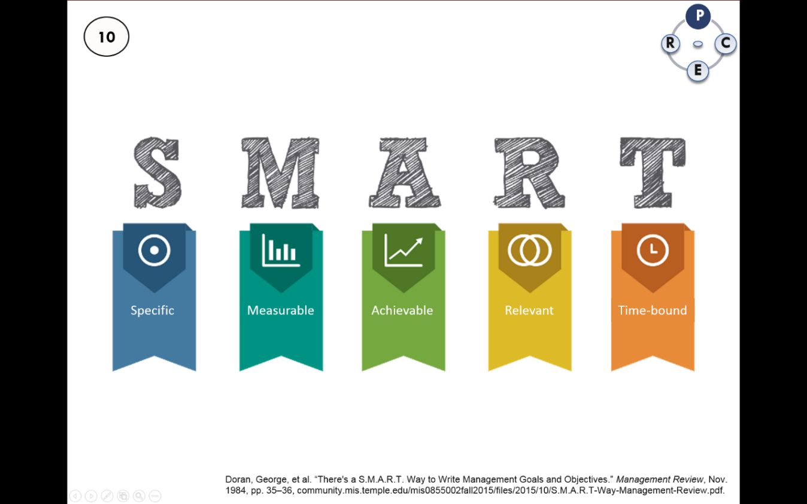

(Doran, 1981)

The best Performance Goals are:

* **Specific**: A goal should be written with enough detail that clearly defines what the employee is expected to accomplish.
* **Measurable**: A goal should specify how success will be measured – generally in terms of quantity, timeliness, quality and/or cost.
* **Achievable**: A goal should stretch and challenge an employee and be attainable given necessary support and resources.
* **Relevant**: A goal should be appropriate for the employee’s position and aligned to the organization’s overall goals.
* **Time-bound**: A goal should have one or more target dates to guide the employee to a successful and timely completion.

**Examples of SMART Goals:**

* Lead the department’s continuous improvement team to create and implement a customer satisfaction survey. Draft survey will be presented for comment at the August staff meeting. Survey will be implemented by September 30.
* Review the department’s customer service surveys, prepare summary reports using the established report template, and email the reports to the director by the 1st of each month.
* Develop a guide using MS Word for new employees on the department’s customer service values and protocols. Draft is due October 31, and final guide will be included in the January new employee orientation.
* Implement the automated call attendant system by August 31 so that it can be scheduled in advance and remotely activated during times of emergency.

**TIP:** When establishing performance goals, be sure to discuss the resources and support that will be required and provided for the employee to be successful! Examples: bi-weekly meetings with supervisor will be scheduled to review progress; employee will attend an advanced class in MS Excel; front office schedule will be adjusted so employee will be able to dedicate 4 hours per week on project until completion.