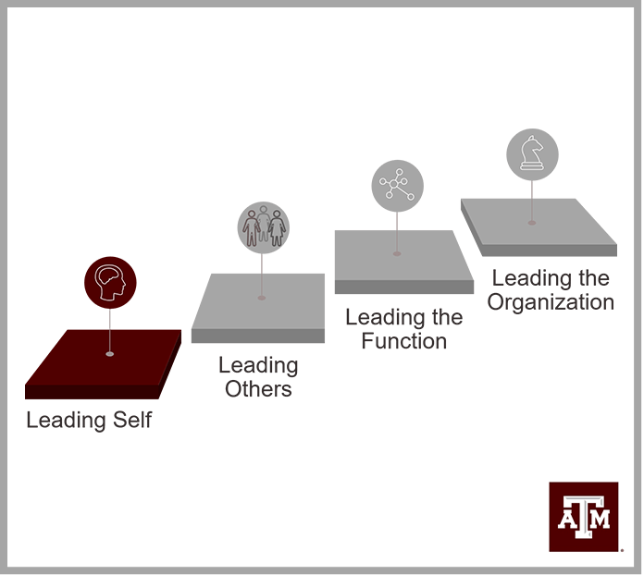
Leading Self
Manager’s Guide

What Participants are Saying…
“The Leading Self program helped me connect my past learning and experiences to my current role at the university and demonstrated to me that TAMU places importance in the value of each employee making contributions to the success of the university. We had the opportunity to connect the dots by having meaningful discussions with our classmates and also role play. I am a member of the Leading Self-community, and its’s part of my identity now.”
Mona Somers
Executive Assistant
Office of Vice President for Research

“I would encourage anyone to enroll in Leading Self who is wanting to grow. Even if it's just foundation, even if you're just started with us yesterday or you've been with us for 10 years and maybe you're not sure what that next step is, whether it's in your professional, personal, or just your life journey of learning.”
Kristin Ebner
Business Coordinator
College of Education and Human Development

“[Leading Self] has helped me develop as a leader at Texas A&M. It has broadened my understanding of what constitutes a leader and how the combined areas that we studied are in harmony with each other and all work together to support and impact the whole concept of what being a leader really is.”
Jill Stickler
IT Business Analyst
Division of Student Affairs

“I am big on application myself and I think the scenarios, back to the Leading Self program, there were a lot of scenarios that were close to real life. A lot of people were nodding their heads when these scenarios were put out and that helps us go forward with that because it's like, “Yeah, I dealt with that like two weeks ago”, and it's not just some arbitrary [scenario].”
Michael Phillips
Software Applications Developer
Division of Information Technology

Table of Contents
Leadership Development at Texas A&M 1
Leading Self Leadership Development Program 2
Learning Journey 2
Program Completion Requirements 3
Program Materials 3
How to Use This Guide 5
Milestone 1: Introduction to Leading Self 6
Milestone 2: Texas A&M University’s Mission, Vision, and Values 8
Milestone 3: Interpersonal Effectiveness 11
Milestone 5: Customer Service 19
Milestone 6: Problem Solving and Process Improvement 22
Milestone 7: Adapting to Change 25
Learning and Development (L&D) Plan 28
Learning & Development Plan Process 28
Learning & Development Plan: Supervisor Guide 31

Leadership Development at Texas A&M
Texas A&M’s leadership development follows a competency-based, progressive development model framed around four (4) levels.
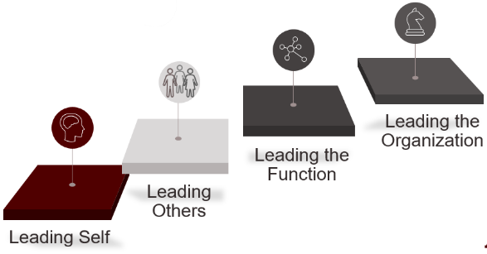
- Leading Self
- Leading Others
- Leading the Function
- Leading the Organization

At each level, a leadership development program supports the development of core competencies for the different leadership roles across the university through a blended approach comprised of curriculum, assessments, network events, and action learning projects (for some roles) to help employees gain awareness, learn and practice, and continue to develop what they need to know and do as they transform into leaders competent in leading people at the University

Gain awareness
To help employees gain awareness, each leadership development program includes individual assessments, such as Myers-Briggs Type Indicator, and program assessments – pre/post-assessments used to determine knowledge gained.

Learn and practice
Each leadership development program helps employees learn and practice through on-demand and self-directed learning activities, as well as through highly experiential in-person and virtual learning activities.

Continue to develop
To help employees continue to develop, each leadership development program includes resources to support application of knowledge, skills, and abilities back on the job, in their work units and departments.

Leading Self Leadership Development Program
Everyone is a leader – you do not have to be a supervisor or manager to lead at Texas A&M University. Following the progressive leadership development framework, the Leading Self leadership development program helps university employees build foundational leadership competencies to enable a common language, practice, and culture across the university community.

The Leading Self leadership development program focuses on six competencies:
- TAMU Mission, Vision, Values;
- Interpersonal Effectiveness;
- Customer Service;
- Problem Solving and Process Improvement; and
- Adapting to Change.

Learning Journey
The Leading Self leadership development program follows a blended-learning design which includes assessments, courses, evaluations, and self-studies. The Leading Self learning journey provides participants the flexibility to complete the program at their own pace over a 12-month period.

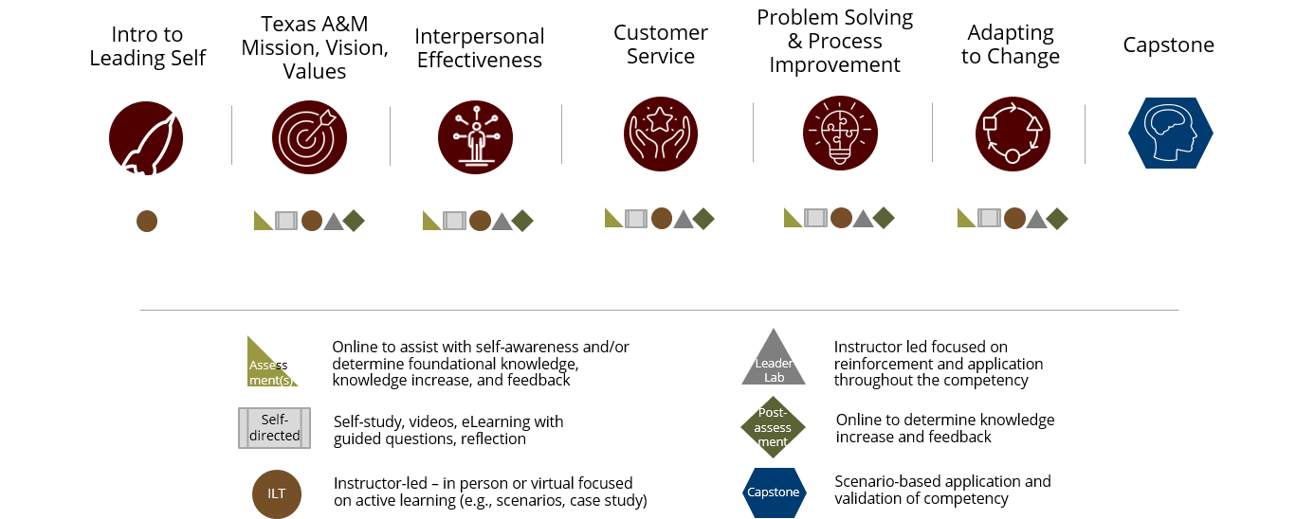

Program Completion Requirements
There are two general requirements for completing this leadership development program successfully.
- Complete all learning activities (i.e., pre/post-assessments, courses, course evaluations, course prep assignments, self-studies).
- Create a learning and development plan as part of the Leading Self Capstone course.

Program Materials
Participants will receive the following materials for use during and after the program.
- Copy of Co-Active Leadership: Five Ways to Lead by Karen and Henry Kimsey-House
- Leadership Journal
- Personal Impact Report by The Myers-Briggs Company
- Copy of Introduction to Myers-Briggs Type booklet
- Copy of Introduction to Myers-Briggs Type and Communication booklet
- Copy of Introduction to Type and Conflict booklet
- Copy of Introduction to Myers-Briggs Type and Change booklet
- Participants guides for in-person and virtual courses
- Leading Self messenger bag
- Leading Self leather writing journal
- Maroon pen

Leadership Journal
The Leadership Journal provides information to help participants successfully complete the Leading Self leadership development program.

The six (6) competency sections in the Leadership Journal
- provide guidance to completing the designated learning activities and
- conclude with a Reflection assignment to help deepen participants’ level of learning.

The Capstone section of the Leadership Journal contains an employee guide, as well as a template for the Learning and Development Plan, which guides participants through creating a customized learning and development plan as they are finishing Leading Self.

An appendix provides a list of additional resources.

How to Use This Guide
As a supervisor, you can be a powerful ally in ensuring employees have the resources necessary to successfully complete the Leading Self leadership development program. Therefore, we recommend that you engage with employees at the start, throughout, and at the end of their learning journey.

This guide provides you with recommended practices to best support employees as they navigate their Leading Self learning journey, such as

- knowledge, skills, and abilities developed by employees;
- employee and supervisor responsibilities; and
- considerations for providing feedback and support to employees.

We recommend that you meet with the employees at each milestone, at a minimum, to discuss the value and impact Leading Self is having on them, their behavior, and their work. Just as this guide provides you with recommended practices for having these milestone discussions, employees have reflections at the end of each competency section in their Leadership Journal to guide them in these discussions.

The Learning & Development (L&D) Plan section of this guide provides resources to help successfully navigate and participate in the L&D Plan process. This section includes:
- The L&D Plan Process
- L&D Plan – Supervisor Guide

Milestone 1: Introduction to Leading Self
The first milestone occurs at the beginning of the employee’s learning journey, after they have attended the “Introduction to Leading Self” course.

Roles and Responsibilities
Employee | Supervisor
- Schedules a 30-minute meeting with their supervisor and shares:  - The Leading Self learning journey  - Time needed to complete designated learning activities  - How supervisor can best support their learning and development | - Attends the meeting with the employee and shares:  - Expectations for completing Leading Self leadership development program  - Expectations for seeking and receiving updates on the employee’s progress.

The Milestone Discussion
Consider the following when preparing for this milestone discussion:
- What expectations do you have for the employees as they navigate the Leading Self learning journey to complete the Leading Self leadership development program?
  - What would you like them to get out of the program? What knowledge, skills, abilities and behaviors would you like them to develop?
  - What resources can you provide to support your employees’ learning and development?
Click or tap here to enter text.
- In addition, how frequently would you like to receive updates regarding the employees’ progress on completing the Leading Self leadership development program? For example, every other week, every month, at the end of each competency?
Click or tap here to enter text.

- What would you like to hear from them about what they are learning, what they would like to practice back on the job, and how you can help?
Click or tap here to enter text.
- How would you prefer to receive these updates from the employees regarding their progress?
Click or tap here to enter text.

Milestone 2: Texas A&M University’s Mission, Vision, and Values
Upon completion of the designated learning activities for this competency, employees should be able to demonstrate the following knowledge, skills, and abilities:
Defines mission, vision, and values.
Recognizes the following:
- History and traditions of Texas A&M University;
- Texas A&M University’s Mission, Vision, Values;
- Texas A&M University’s organization structure, including relationship with Texas A&M University System;
- Role, responsibility, and implications of being a public university; and,
- Considerations for and implications of being designated as a land, sea, and space grant university and a Tier 1 Research institution.
Recognizes the importance of aligning behavior and work with the university’s mission, vision, and values.
Recognizes how the university’s Mission, Vision, Values, and Structure impact interpersonal effectiveness, change, and customer service.
Identifies how role supports own unit and the university’s mission and vision.
Recognizes resources to support Texas A&M University mission, vision, and values.
Identifies opportunities to develop and learn to improve self and the university.
Contributes to an environment that upholds the university’s mission, vision, and values through own behaviors, actions, and work.
Speaks up in a respectful manner and takes action through appropriate channels when the university’s values are not demonstrated.
Supports those who speak up and those who take action to uphold the university’s values.
Seeks and participates in opportunities to learn, develop, and improve self and the university.

Roles and Responsibilities
Employee | Supervisor
- Schedules a meeting with their supervisor to:  - Share their progress on the learning journey  - Share what they are learning and the value and impact of what they are learning  - Share how they have applied or would like to apply the learning on the job  - Discuss how the supervisor can support them and/or provide feedback on how well their supervisor is supporting their learning and developing thus far  - Address any barriers to their learning and development | - Attends the meeting with your employee.  - Listens to the employee’s insight on their progress, learning, and application of learning from the program thus far.  - When needed, seek to further understand by asking clarifying questions and/or examples  - Provides feedback to employee regarding changes to behavior, actions, work, and results.  - Identifies additional opportunities to enhance application of learning and development  - Helps assist with any issues or barrier identified by the employee, including what additional supervisor support they may need.

The Milestone Discussion
Consider the following when preparing for this milestone discussion:
- Identify specific examples of when you observed the employee
  - Contributing to an environment that upholds the university’s mission, vision, and values through own behaviors, actions, and work.
  - Speaking up in a respectful manner and taking action through appropriate channels when the university’s values are not demonstrated.
  - Supporting those who speak up and those who take action to uphold the university’s values.
  - Seeking and participating in opportunities to learn, develop, and improve self and the university.
- Missed opportunities for the employees to apply their leadership by not demonstrating the above.
- Opportunities for the employees to continue developing and improving their leadership skills.
- Opportunities for the employees to influence or lead in their role, within the work unit or department, and/or across the university community.

Click or tap here to enter text.

Milestone 3: Interpersonal Effectiveness
Upon completion of the designated learning activities for this competency, employees should be able to demonstrate the following knowledge, skills, and abilities:
Recognizes interpersonal preferences, including common misconceptions, as well as the value of diverse interpersonal preferences.
Identifies own interpersonal preferences, including development opportunities and considerations for working with others.
Recognizes how identifying own and others’ interpersonal preferences can help with or hinder building positive interpersonal relationships and working collaboratively with others.
Defines professionalism in the workplace, including:
- Appearance,
- Attitude,
- Work Ethic,
- Communicating and interacting with others.
Differentiates between professional and unprofessional appearance, attitude, communication, and work ethic.
Recognizes common professional written, verbal, and non-verbal communication practices.
Distinguishes between common communication approaches to foster collaboration, resolve interpersonal conflict, and exercise influence.
Recognizes resources for resolving interpersonal conflict.
Recognizes the importance of managing own work responsibilities, including time management and prioritization.
Recognizes the purpose and process for meeting established performance expectations, including:
- Performance management process (e.g., PCER model, goals, etc.)
- Receiving, seeking, and providing feedback
- Performance evaluation
Recognizes how interpersonal effectiveness impacts the university’s mission, vision, values; customer service; problem solving and process improvement; and adapting to change.
Represents self, position, work unit, and the university professionally in appearance, attitude, communication, and work ethic when interacting with others.
Builds and maintains positive interpersonal relationships that foster mutual trust and respect with others.
Works in a cooperative and collaborative manner with others.
Demonstrates appropriate and professional verbal, nonverbal, and written communication.
Resolves interpersonal conflicts constructively, using appropriate resources, and escalates appropriately.
Holds self-accountable for meeting established performance expectations and work responsibilities, communicating barriers and challenges proactively.
Prioritizes work responsibilities, with appropriate level of guidance, to achieve work and desired outcome.

Roles and Responsibilities
Employee | Supervisor
- Schedules a meeting with their supervisor to:  - Share their progress on the learning journey  - Share what they are learning and the value and impact of what they are learning  - Share how they have applied or would like to apply the learning on the job  - Discuss how the supervisor can support them and/or provide feedback on how well their supervisor is supporting their learning and development thus far.  - Address any barriers to their learning and development | - Attends the meeting with the employee.  - Listens to the employee’s insight on their progress, learning, and application of learning from the program thus far.  - When needed, seek to further understand by asking clarifying questions and/or examples  - Provides feedback to employee regarding changes to behavior, actions, work, and results.  - Identifies additional opportunities to enhance application of learning and development  - Helps assist with any issues or barrier identified by the employee, including what additional supervisor support they may need.

The Milestone Discussion
Consider the following when preparing for this milestone discussion:
- Identify specific examples of when you observed the employees
  - Representing themself, their position, work unit, and the university professionally in appearance, attitude, communication, and work ethic when interacting with others.
  - Building and maintaining positive interpersonal relationships that foster mutual trust and respect with others.
  - Working in a cooperative and collaborative manner with others.
  - Demonstrating appropriate and professional verbal, nonverbal, and written communication.
  - Resolving interpersonal conflicts constructively, using appropriate resources, and escalating issues appropriately.
  - Holding themself accountable for meeting established performance expectations and work responsibilities, communicating barriers and challenges proactively.
  - Prioritizing their work responsibilities, with appropriate level of guidance, to achieve work and desired outcomes.
- Missed opportunities for the employees to apply their leadership by not demonstrating the above.
- Opportunities for the employees to continue developing and improving their leadership skills.
- Opportunities for the employees to influence or lead in their role, within the work unit or department, and/or across the university community.

Click or tap here to enter text.

Milestone 5: Customer Service
Upon completion of the designated learning activities for this competency, employees should be able to demonstrate the following knowledge, skills, and abilities:
Identifies customers.
Recognizes the importance of customer service on the work environment and organization, as well as what influences good and poor customer service.
Recognizes key components of delivering good customer service, including:
- Professional interactions (e.g., greeting, procedures, follow through, etc.);
- Understanding customer wants, needs, and expectations.
- Mutual trust, respect, and collaboration.
- Customer focused communication practices (e.g., face to face, phone, email, etc.); and
- Resources.
Recognizes common approaches for potential and realized difficult situations, taking into consideration:
- Strong emotions – personal triggers and customer triggers.
- Situation and environment; and
- Resources and solutions to improve the customer’s experience.
Recognize how interpersonal effectiveness; mission, vision, and values; and problem solving and process improvement impact customer service.
Contributes to an environment of excellent customer service.
Builds and maintains relationships with customers that foster mutual trust, respect, collaboration, and follow through on commitments.
Anticipates and responds appropriately to the needs of customers to improve service and relationships.
Responds to potential and realized difficult situations, using appropriate approach, to improve the customer’s experience.

Roles and Responsibilities
Employee | Supervisor
- Schedules a meeting with their supervisor to:  - Share their progress on the learning journey  - Share what they are learning and the value and impact of what they are learning  - Share how they have applied or would like to apply the learning on the job  - Discuss how the supervisor can support them and/or provide feedback on how well their supervisor is supporting their learning and developing thus far.  - Address any barriers to their learning and development | - Attends the meeting with the employee.  - Listens to the employee’s insight on their progress, learning, and application of learning from the program thus far.  - When needed, seek to further understand by asking clarifying questions and/or examples  - Provides feedback to employee regarding changes to behavior, actions, work, and results.  - Identifies additional opportunities to enhance application of learning and development  - Helps assist with any issues or barrier identified by the employee, including what additional supervisor support they may need

The Milestone Discussion
Consider the following when preparing for this milestone discussion:
- Identify specific examples of when you observed the employees
  - Contributing to an environment of excellent customer service.
  - Building and maintaining relationships with customers that foster mutual trust, respect, collaboration, and follow through on commitments.
  - Anticipating and responding appropriately to the needs of customers to improve service and relationships.
  - Responding to potential and realized difficult situations, using appropriate approach, to improve the customer’s experience.
- Missed opportunities for the employees to apply their leadership by not demonstrating the above.
- Opportunities for the employees to continue developing and improving their leadership skills.
- Opportunities for the employees to influence or lead in their role, within the work unit or department, and/or across the university community.

Click or tap here to enter text.

Milestone 6: Problem Solving and Process Improvement
Upon completion of the designated learning activities for this competency, employees should be able to demonstrate the following knowledge, skills, and abilities:
Defines problem solving and process improvement.
Recognizes the purpose and value of problem solving and process improvement; and, the impact of not addressing problems and seeking improvements.
Recognizes role and responsibility in problem solving and process improvement.
Recognizes the relationship between growth mindset, critical thinking skills, assumptions and biases; and, impact on problem solving and process improvement.
Recognizes common problem-solving practices and tools for:
- identifying root cause,
- developing a problem statement,
- identifying possible solutions, and
- developing recommendations.
Recognizes relationship between decision-making, problem solving, and process improvement to present recommendations to decision makers.
Differentiates between problem solving and process improvement.
Recognize common process improvement practices and tools, including considerations for implementation and sustainment.
Recognizes the relationship between Texas A&M University’s mission, vision, values; interpersonal effectiveness; customer service; and adapting to change.
Seeks opportunities to improve own work and that of the work unit.
Takes action to resolve problems, using appropriate practices and tools; and, proactively escalates problems as needed.
Makes constructive recommendations to improve processes; and, implements recommendations with appropriate level of guidance.
Seeks the reason behind decisions regarding problem solving and process improvement efforts.
Raises awareness of potential problems and improvement opportunities to appropriate people.

Roles and Responsibilities
Employee | Supervisor
- Schedules a meeting with their supervisor to:  - Share their progress on the learning journey  - Share what they are learning and the value and impact of what they are learning  - Share how they have applied or would like to apply the learning on the job  - Discuss how the supervisor can support them and/or provide feedback on how well their supervisor is supporting their learning and developing thus far.  - Address any barriers to their learning and development | - Attends the meeting with the employee.  - Listens to the employee’s insight on their progress, learning, and application of learning from the program thus far.  - When needed, seek to further understand by asking clarifying questions and/or examples  - Provides feedback to employee regarding changes to behavior, actions, work, and results.  - Identifies additional opportunities to enhance application of learning and development  - Helps assist with any issues or barrier identified by the employee, including what additional supervisor support they may need

The Milestone Discussion
Consider the following when preparing for this milestone discussion:
- Identify specific examples of when you observed the employees
  - Seeking opportunities to improve own work and that of the work unit.
  - Taking action to resolve problems, using appropriate practices and tools; and proactively escalating problems as needed.
  - Making constructive recommendations to improve processes; and implementing recommendations with appropriate level of guidance.
  - Seeking the reason behind decisions regarding problem solving and process improvement efforts.
  - Raising awareness of potential problems and improvement opportunities to appropriate people.
- Missed opportunities for the employees to apply their leadership by not demonstrating the above.
- Opportunities for the employees to continue developing and improving their leadership skills.
- Opportunities for the employees to influence or lead in their role, within the work unit or department, and/or across the university community.

Click or tap here to enter text.

Milestone 7: Adapting to Change
Upon completion of the designated learning activities for this competency, employees should be able to demonstrate the following knowledge, skills, and abilities:
Defines change and transition.
Recognizes potential reactions and barriers to change success.
Identifies the purpose and value of change.
Recognizes common approaches to change, including tradeoffs and considerations.
Identifies own approach to change.
Recognizes role and responsibility for change success.
Recognizes how individual approaches to change can help or hinder change success.
Identifies resources and tools to help self and others transition and adapt to change.
Recognizes the relationship between Texas A&M University’s mission, vision, values; interpersonal effectiveness; customer service; and problem solving and process improvement.
Supports change that enables their work unit and the university’s improvement and future direction.
Approaches change with curiosity and adaptability.
Seeks clarity on what is changing, the reason for the change, how it will impact them, and their role and responsibility during change.
Manages own transition during change successfully; and, supports others during transition.
Helps identify issues and risks to change success and escalates appropriate.

Roles and Responsibilities
Employee | Supervisor
- Schedules a meeting with their supervisor to:  - Share their progress on the learning journey  - Share what they are learning and the value and impact of what they are learning  - Share how they have applied or would like to apply the learning on the job  - Discuss how the supervisor can support them and/or provide feedback on how well their supervisor is supporting their learning and developing thus far.  - Address any barriers to their learning and development | - Attends the meeting with the employee.  - Listens to the employee’s insight on their progress, learning, and application of learning from the program thus far.  - When needed, seek to further understand by asking clarifying questions and/or examples  - Provides feedback to employee regarding changes to behavior, actions, work, and results.  - Identifies additional opportunities to enhance application of learning and development  - Helps assist with any issues or barrier identified by the employee, including what additional supervisor support they may need

The Milestone Discussion
Consider the following when preparing for this milestone discussion:
- Identify specific examples of when you observed the employees
  - Supporting change that enables their work unit and the university’s improvement and future direction.
  - Approaching change with curiosity and adaptability.
  - Seeking clarity on what is changing, the reason for the change, how it will impact them, and their role and responsibility during change.
  - Managing own transition during change successfully; and supporting others during transition.
  - Helping identify issues and risks to change success and escalates appropriately.
- Missed opportunities for the employees to apply their leadership by not demonstrating the above.
- Opportunities for the employees to continue developing and improving their leadership skills.
- Opportunities for the employees to influence or lead in their role, within the work unit or department, and/or across the university community.

Click or tap here to enter text.

Learning and Development (L&D) Plan
We recommend Leading Self participants initiate the L&D Plan process as they begin the final competency in the Leading Self learning journey, Adapting to Change.

There are four (4) phases to the L&D Plan process:
- Initiate
- Awareness & Assessment
- Development Discussion
- Implementation

Participants are expected to complete Phase 2: Awareness & Assessment of the L&D Plan process prior to attending the Leading Self Capstone course. During the Leading Self Capstone course, participants are asked to share their drafted L&D Plan with their peers. They are encouraged to complete Phases 3 and 4 of the L&D Plan process following their successful completion of the Leading Self leadership development program.

Learning & Development Plan Process
This table explains the role of the employee and the supervisor during each of the four phases of the L&D Plan process.
Phase | Employee | Supervisor
- Initiate | - Schedules a meeting with supervisor to inform of intent to create and pursue a L&D Plan.  - Discusses the process for the L&D Plan.  - Secures agreement and support. | - Attends the meeting  - Asks clarifying questions as needed.  - Agrees to support development of the L&D Plan.
- Awareness & Assessment | - Identifies current and / or desired role and responsibilities (e.g., further development in current role or pursue another role in the organization).  - Takes into account the organization’s needs.  - Identifies competencies needed for current and/or desired role and responsibilities.  - Assesses own current competencies – knowledge, skills, abilities, behaviors, and even experience.  - Identifies needed strengths, knowledge, skills, competencies, development, and experience need for current and / or future role.  - Identifies learning activities to help improve competence and capability for current and / or desired roles and responsibilities.  - Prioritizes learning & development activities.  - Creates a draft L&D Plan. | - Determines the employee’s strengths and development opportunities.  - Considers the:  - Employee’s competencies – knowledge, skills, abilities, behaviors, and even experiences.  - Most recent performance goals and evaluation.  - Roles you think the employee might be interested in and/or good at.  - Potential L&D activities to support or create for the employee.  - Business needs of the unit, department, college / division, university.  - Resources available.
- Development Discussion | - Schedules a meeting with supervisor.  - Prepares an agenda.  - Leads the discussion.  - Presents the proposed L&D Plan.  - Is open to questions, feedback, and changes to your L&D Plan. | - Brings prepared notes.  - Allows employee to lead.  - Helps employee think through the plan, such as appropriate competencies, L&D activities, business needs or considerations and realistic timing.  - Determines resources and support the employee might need to enable their success (e.g., money, time, other people, introductions, follow up check ins with you, etc.)
- Implementation | - Edits and finalize the L&D Plan.  - Schedules a second meeting as needed to review the revised L&D Plan  - Sends the finalized plan to supervisor.  - Assumes ownership and act on the plan.  - Schedules deadlines and follow up meetings.  - Revises as needed with supervisor.  - Secures agreement and support throughout the process. | - Helps the employee secure resources.  - Follows up or check-in on progress – their accomplishments, what are they learning, and could they apply or practice to further their learning.  - Supports and encourages the employee.  - Provides ongoing feedback.  - Provides opportunities for the employee to continue practicing and strengthening their L&D competency.

Learning & Development Plan: Supervisor Guide
The L&D Plan process is owned and managed by the employee, in partnership with you, their supervisor, to enable their learning and development. This guide provides information to help you partner with employees to create their L&D Plan in alignment with organizational needs and goals.

Phase One – Initiate
During this phase, employees will initiate the L&D Plan process by meeting with you, their supervisor. See the L&D Plan Process section for additional details.

In preparation for the meeting with employees, consider the following question:
- What is the benefit of employees creating and pursuing a learning and development plan? How could it help them, your team, and the university?
Click or tap here to enter text.

Phase Two – Awareness and Assessment
During this phase, the employees will gain further awareness of organizational needs and goals and their current competencies (knowledge, skills, and abilities) and experiences; identify desired competencies, experiences, roles and responsibilities; and, assess needed competencies and experiences to achieve their current and desired roles and responsibilities. This information is used by employees to draft their individual L&D Plan, which will be discussed in Phase 3 of the Learning and Development Plan process.

Organizational Assessment
Consider the questions below in preparation for your discussion in Phase 3:
- What are the current and future needs of the organization (e.g., mission, strategy, leadership, competency, etc.)?
Click or tap here to enter text.
- What are the current and future goals of the organization?
Click or tap here to enter text.
- What competencies (knowledge, skills, abilities) are needed?
Click or tap here to enter text.
- Do you have employees who have these competencies? Do they need to be developed?
Click or tap here to enter text.

Individual Assessment
Consider the questions below in preparation for your discussion in Phase 3:
- How can the employee contribute or develop to meet the organization’s needs and goals – current and future?
Click or tap here to enter text.
- What do you see as the employee’s strengths?
Click or tap here to enter text.
- What do you see as the employee’s development opportunities?
Click or tap here to enter text.
- What do you see as the employee’s competencies – knowledge, skills, abilities, behaviors, and experiences that can be developed?
Click or tap here to enter text.
- What role(s) might the employee be interested in or good at?
Click or tap here to enter text.
- How might learning and development activities help the employee achieve performance goals on the most recent performance appraisal?
Click or tap here to enter text.
- What are some on-the-job or organizational (e.g., committees, professional organizations) activities that would provide learning and development for the employee?
Click or tap here to enter text.

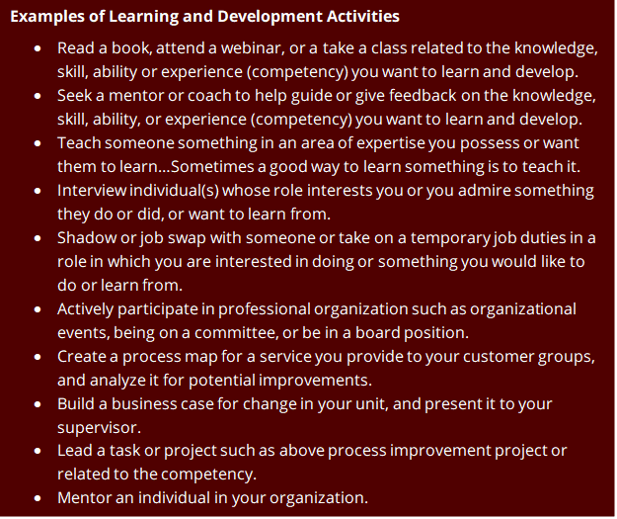

Phase Three – Learning & Development Discussion
During this phase, you and the employees collaborate to refine their L&D Plan. Their refined L&D Plan is used in Phase 4 of the L&D Plan process. See the L&D Plan Process section for additional details.

In preparation for this discussion, consider the following questions:
- What questions might you expect from the employee?
Click or tap here to enter text.
- What feedback are you prepared to give the employee?
Click or tap here to enter text.
- What resources are you able to provide in support of the employee’s learning & development (e.g., money, time, other people, introductions, etc.)?
Click or tap here to enter text.

Phase Four – Implementing the Plan
This phase is about ensuring the employees’ successful implementation of their L&D Plan. It is their responsibility to monitor their progress and provide feedback to you, their supervisor, to ensure alignment and on-going support.

Consider the following questions:
- What expectations do you have for the employee as they execute their L&D Plan?
Click or tap here to enter text.
- How frequently would you like to receive updates regarding their progress? For example, every other week, every month?
Click or tap here to enter text.
- How would you prefer to receive these updates from the employee regarding their progress?
Click or tap here to enter text.
- What would you like to hear from the employee? For example, what they are learning, what they would like to practice back on the job, and how you can help?
Click or tap here to enter text.
- How frequently will you provide the employee with feedback?
Click or tap here to enter text.

Learn more about
our future direction and new programming at
OrgDev.tamu.edu

