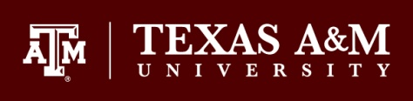
(APPROPRIATE LETTERHEAD)

MEMORANDUM

Date

TO: (Appropriate Vice President or Provost and Executive Vice President)

THROUGH: Damon Slaydon (Exceeding Maximum)
Vice President for Human Resources and Organizational Effectiveness

FROM:

SUBJECT: Job Related Skill Enhancement – Upper Band or over Maximum

Position ID & Title:
Employee Name:
Employee UIN:
Current Salary:
Proposed Salary and Percentage Increase:
Proposed Effective Date of Salary Adjustment:

{DEPARTMENT} is requesting approval of a Job-Related Skill Enhancement Increase that is exceeding the pay plan maximum for {EMPLOYEE} in accordance with Standard Administrative Procedure 31.01.01.M7.05, Job-Related Skill Enhancement Pay.

The department certifies that the employee took the initiative through their own efforts to increase their job worth and significantly enhance their value to their organization by obtaining a degree, certificate, license or other evidence of completion of a prescribed program. The increase is given within six (6) months of the date the certification is awarded. The department verified the authenticity of the degree, certificate, license or other evidence of completion of a prescribed program presented by the employee. The employee has a "meets expectations" or higher overall rating on the most recent Performance Review, and the employee has not received a Job-Related Skill Enhancement Pay increase within the last twelve (12) months.

