**Accessing MyTRS and Requesting a Refund**

Access your MyTRS account and apply for a refund by following these steps.

1. **Locate TRS Temporary ID number or your TRS Participant ID Number.**
   1. Temporary ID number may be provided by TAMU Tax Compliance & Reporting
   2. You can find your TRS Participant ID number in your welcome to TRS membership packet or on your annual statements. TRS will not provide your participant ID number over the phone. You may speak with a TRS Benefit Counselor and request a copy of your latest statement to be mailed to you, but you need to make sure TRS has the correct address on file first.
2. **Verify or change your address with TRS.** You will need to know your previous address with TRS (most likely the address on file upon your hire) to change your address. Follow the process below to update your address with TRS (if needed).

**Change mailing address with TRS**

* 1. TRS Address Change Form: [TRS 358](https://urldefense.com/v3/__https:/www.trs.texas.gov/TRS*20Documents/form_358.pdf__;JQ!!KwNVnqRv!ECcu6lTh7ssorEyaZKk9rhFNlaOzQ7QXVYZLYbpSQkSLtpgtIYQp4cSKTDFtD3_WDUt1Ab9S1Xvx06kcsRpU4egOk_l2wVLTJDKI$)
     1. The form can be [mailed to TRS](https://www.trs.texas.gov/Pages/about_contacts_us.aspx) or uploaded using secure [Upload Member Forms and Documents](https://www.trs.texas.gov/Pages/UploadMemberFormsandDocuments.aspx) (recommended) option on TRS website.
  2. MyTRS
     1. If you have an established MyTRS account, your mailing address can be updated within MyTRS.

1. **Establish your MyTRS Account (TRS Participant ID Number or Social Security Number Required – go to step 4b if information is unavailable)**
   1. If you have an SSN:
      1. Follow the instructions in the How to [Establish Your MyTRS Account](https://www.trs.texas.gov/sites/default/files/migrated/mytrs-establish-account-instructions.pdf) document on the TRS website. Be aware of these [MyTRS Registration reminders](https://www.trs.texas.gov/pension-benefits/know-benefits/manage-account/register-mytrs/mytrs-registration-reminders).
   2. If you don’t have an SSN:
      1. You will need to know your TRS Participant ID number, found on your annual statements. If you do not have that, you will not initially get past the next screen asking for SSN. Call TRS and ask them to send a copy of your latest statement to you via mail. Change your address prior to this request, if needed.
      2. On the “Identify Yourself as a TRS Member” screen, check the box indicated you do not have an SSN on file. This changes the SSN field to Participant ID. Then if applicable, you will also check the box for a foreign address.

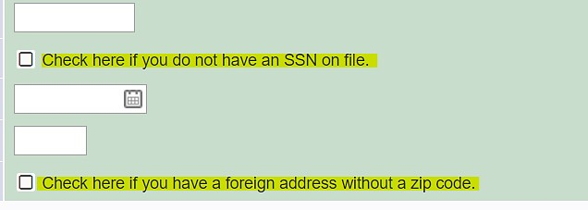

* + 1. After filling out the information, you will get an error and information to download the TRS608 by clicking on the hyperlink provided on the screen.

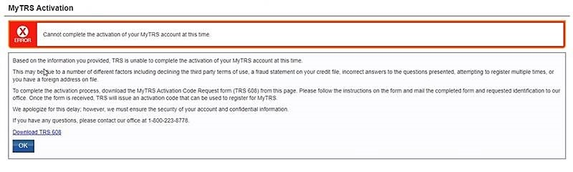

* + 1. You will need to download and complete the TRS608, then [mail it to TRS](https://www.trs.texas.gov/contact). The form says to submit a US ID but if you reside in a foreign country - i.e. Qatar, you may submit a government issued ID that includes a picture and Date of Birth.

1. **Apply for a refund**
   1. MyTRS
      1. The easiest way to apply for a refund is online through MyTRS. Login to your account, navigate to the Benefits tab and click “Apply for a Refund.” Complete the form; then, submit your information. MyTRS helps TRS process the refund request more quickly.
   2. TRS 6 Form (Social Security Number and TRS Participant ID Number NOT available)
      1. You can complete a paper form [TRS 6](https://www.trs.texas.gov/sites/default/files/migrated/form_6.pdf), Application for Refund, available on the Forms page on the TRS website. You will need to complete the form, then sign the application, and have it notarized. The form can be [mailed to TRS](https://www.trs.texas.gov/Pages/about_contacts_us.aspx) or uploaded using secure [Upload Member Forms and Documents](https://www.trs.texas.gov/Pages/UploadMemberFormsandDocuments.aspx) (recommended) option on TRS website.  
         TRS Mailing Address: 1000 Red River St., Austin, TX 78701
      2. [TRS 6 Application for Refund Instructions](https://www.trs.texas.gov/sites/default/files/migrated/form-6IN-instructions.pdf)
   3. Additional Refund Resources
      1. [Requesting a Refund Brochure (pdf)](https://www.trs.texas.gov/sites/default/files/migrated/request_refund.pdf)
      2. [TRS Account Withdrawal Process and Timeline (pdf)](https://www.trs.texas.gov/sites/default/files/migrated/active_member_account_withdrawal.pdf)
      3. [TRS Financial Awareness Video – Should I Get a Refund?](https://www.youtube.com/watch?app=desktop&v=cS_tYYAE2As)
   4. Considerations for employees without a Social Security Number (SSN)
      1. Payments cannot be made via direct deposit to a bank that is located outside of the U.S. The payment will need to be issued via check and will be mailed to the address on file with TRS.

*“Refund payments not rolled over can be issued as a direct deposit or check. To speed up the process and help ensure security, TRS recommends electing direct deposit.*

*All rollover payments will be issued as a check and will be mailed to you at the address listed on your Application Refund form (TRS 6).*

*In some cases, TRS will issue your refund payment as a check even when you select direct deposit. This may happen if the direct deposit information is not fully complete, or if you select a bank that is located outside of the U.S. In addition, if you select direct deposit to a U.S. bank and indicate that 100 percent of the refund will be transferred out of the U.S., you will not be able to receive your refund through direct deposit. In this case, TRR will issue your refund payment as a check.”*

* + 1. **TRS Guidelines for non-U.S. citizens:** “If you are a non-U.S. citizen and a non-resident alien, TRS is required to withhold 30 percent for federal income tax unless you qualify for bene-fits under a U.S. tax treaty. If so, you must notify TRS of your eligibility for reduced withholding or exemption from withholding and provide TRS with a completed IRS Form W-8BEN (Certificate of Foreign Status of Beneficial Owner for United States Tax Withholding) and any other required documentation. The W8BEN can be obtained on the IRS’ website, <www.irs.gov>, or from TRS upon request. TRS recommends that you submit the completed Form W-8BEN with your TRS 6 in order to expedite the processing of your refund.”
    2. **TRS Guidelines on Foreign Trusts:** “A direct rollover may be made to a foreign trust that is a part of a stock bonus, pension, or profit sharing plan established outside the U.S., if the receiving foreign trust would qualify for exemption from tax under Internal Revenue Code (IRC) 401(a) and 501(a), except for the fact that it is a trust created or organized outside the U.S. To claim this exemption, in addition to any other information required by TRS, the distributee must furnish a written statement by an authorized official of the foreign trust stating that the foreign trust is a trust described under IRC 402(d). TRS will not make a transfer to a foreign trust without this statement.”